

<**Title has to be in Each Word Starting with Capital Letters**>

<**Font: -** Times New Roman **Size: -** 24 **Effects: -** Bold >

<Name with Initials>

（Reg. No.: XXXXXXXX）

M.Sc. in <IM/IT>

Specialized in <EAD/ Cyber Security/ Information Systems>

<**Font: -** Times New Roman **Sizes of each above sections: -** 24/16/20 >

Supervisor :　<Title>　<Name>

<**Font: -** Times New Roman **Size: -** 16>

<Month> <Year>

<**Font: -** Times New Roman **Size: -** 16>

<Wording>

**Department of <Each Word Starts with Capital Letters>**

**Faculty of <Each Word Starts with Capital Letters>**

**Sri Lanka Institute of Information Technology**

<**Font: -** Times New Roman **Size: -** 14 **Effects: -** Bold >

**Table of Contents**

Table of Contents 2

List of Figures 3

List of Tables 3

Chapter 1 Formatting Basics 3

1.1 How to add the entries to the TOC 3

1.2 The Styles Added to the template 3

1.2.1 Sub of a Sub Section 3

Chapter 2 Page margins 3

2.1 First Page Margins 3

2.2 Margins of the rest of the Document 3

2.2.1 Right-side Margin 3

2.2.2 Top, Bottom and Left-side Margins 3

Chapter 3 Page Numbering 3

3.1 Page Numbers till the First Chapter 3

3.2 Page Numbers after First Chapter 3

Chapter 4 Applying Styles and Word Count 3

4.1 Styles 3

4.2 Word Count and Plagiarism check 3

How to add References (Bibliography) 3

Appendix 3

Appendix 1: Sub Category of Appendix 3

**List of Figures**

Figure 1.1 Adding Table of Contents 3

Figure 1.2 Styles 3

Figure 2.1 Page Layout 3

Figure 2.2 Set up the page margin 3

Figure 3.1 Page Break 3

Figure 3.2 Adding New Numbering System 3

Figure 3.3 Format Numbers 3

Figure 3.4 Change Options 3

Figure 4.1 Add a Reference 1 3

[Figure 4.2 Create Source](https://mysliit-my.sharepoint.com/personal/nuwan_p_sliit_lk/Documents/Extra%20Work/Thesis%20Template%20Final.dotx#_Toc515956900) 3

Figure 4.3 Source Manager 3

**List of Tables**

Table 1.1 Style Table 3

# Formatting Basics

For the Chapter Headings use **SLIIT_Heading 1**

Every Chapter should be started on a New Page.

## How to add the entries to the TOC

For the sub section headings use **SLIIT_Heading 2**

When you are typing the body text you should select the Paragraphs Style.

You have to follow the below sequence to add records to TOC. You may refer the Fig.1.1 to add the content in to TOC.

For Lists as below use SLIIT_List Style You’ll have to restart the numbering at the beginning of each list.

1. Select the Title you wanted to add to TOC
2. Go to Reference Tab
3. Click on Add Text
4. Select the level that you want to add (Following the Correct Level is an advantage in editing the TOC)
5. Finally click on Update Table

**

*Figure 1.1 Adding Table of Contents*

When editing the TOC, any change done to a particular level such as indentation will be added to all the latter texts in the TOC in same level. The TOC will have to be updated with every headings related to TOC is added.

**Example:** If heading section level 2 is indented with 0.2”; all the latter texts in heading section level 2 will be automatically indented with 0.2”.

## The Styles Added to the template

When you create new chapter, section, or captions, you should select the relevant style Home > Styles.

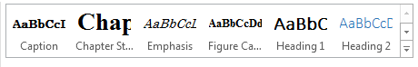

*Figure 1.2 Styles*

Use **SLIIT_Caption** style to adjust the Figures and captions.

*Table 1.1 Style Table*

|  |  |
| --- | --- |
| **Style Name** | **Description** |
| Chapter Style | Format the SLIIT_Heading 1 |
| Subsection 1 Style | Format the SLIIT_Heading 2 |
| Figure Caption | Format the Figure Caption |
| Paragraphs | Format the SLIIT_PARA |
|  |  |
|  |  |

You are free to add the figures to the document to any place within the given margins. Figure captions and the Table captions has to be as follows:

Figure <Chapter#>.<Figure#><space><Caption>

Note that the figure captions have to be at the bottom of the Figure left aligned. Figure captions has to be added as follows. You may refer Figure 1.2

1. Right click on the figure
2. Select insert caption
3. Type the caption
4. Select the label as figure
5. Click OK
6. Finally go the List of Figure page 🡺 Reference tab 🡺 Update Table

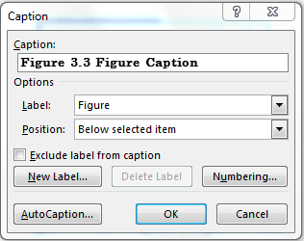

*Figure 1.3 Add a Caption to Figure or Table*

You may use the same method to add Table captions as well. However, note that the table captions should be at the top of the table.

### Sub of a Sub Section

**<SLIIT_Heading 3 – Level 3>**

This is Subsection of a subsection. For the Paragraphs use SLIIT_PARA style.

# Page margins

Page Size: - A4

Under this chapter the Page Margins will be explained.

## First Page Margins

Set the page margins as 1 inch in every side.

## Margins of the rest of the Document

### Right-side Margin

Set the page right-side margin as 0.75 inches.

### Top, Bottom and Left-side Margins

Set all the top, bottom and left-side margin as 1 inch.

Follow the guidelines to set page margin.

1. Go to Page Layout
2. Click the Margins tab and select Custom Margins
3. Enter the relevant margin values to the correct field
4. In the preview select whether need to apply for the selected section or to the whole document from Apply to drop down list.
5. Then click OK to make the changes.

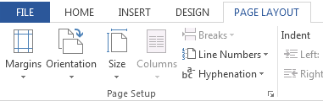

*Figure 2.1 Page Layout*

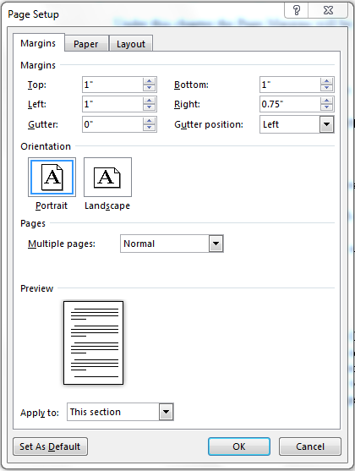

*Figure 2.2 Set up the page margin*

# Page Numbering

How page Numbering of the Document should be will be explained here.

## Page Numbers till the First Chapter

Add Roman Numbering System as Page Numbering System at the lower right side of the footer. Make sure to tick the “Different First Page” Option after selecting the Footer from the new menu appears in the top bar.

## Page Numbers after First Chapter

After the page containing the TOC (Table of Content), add a page break.

**

*Figure 3.1 Page Break*

Then link it with the previous section and add new numbering system (Numeric) and in the dialog box select the option “Continue from the previous section”.

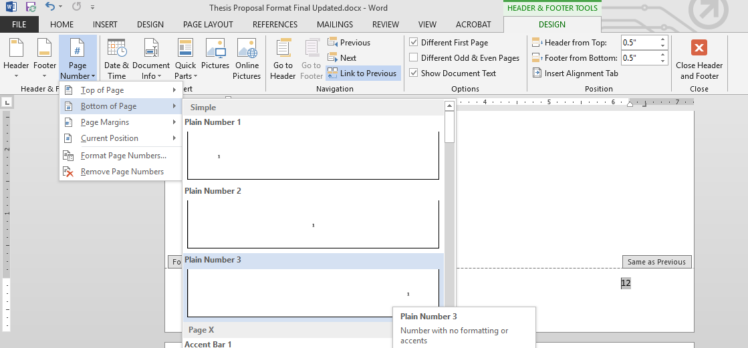

*Figure 3.2 Adding New Numbering System*

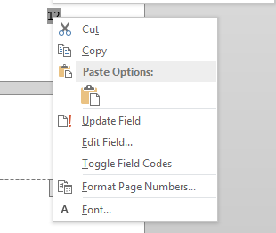

*Figure 3.3 Format Numbers*

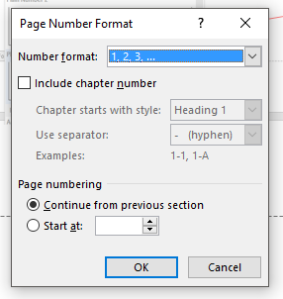

*Figure 3.4 Change Options*

# Applying Styles and Word Count

## Styles

When you are typing the body text you have to make sure that you selected the Paragraphs Style.

You have to follow the below sequence to add records to TOC.

1. Select the Title you wanted to add to TOC
2. Go to Reference Tab
3. Click on Add Text
4. Select the level that you want to add (Level 1)
5. Finally click on Update Table

## Word Count and Plagiarism check

Your Thesis should include a **word count** of **20,000 – 30,000**.

Before you submit your Thesis, you need to check for Plagiarism using the Turnitin Software. Percentage should be **less than 20%**

**How to add References (Bibliography)**

When you add the Reference Page, make sure that you select the SLIIT-Page heading Style for the Heading.

Use **IEEE format** or **APA-6** format.

You need to select the required Style in the Style drop down Menu in the below steps given.

You have to follow the below sequence to add a reference to TOC.

1. Select the Title you wanted to add to TOC
2. Go to Reference Tab
3. Click on Add Text
4. Select the level that you want to add (Level 1)
5. Finally click on Update Table

Guidelines to add a Reference to the page

**

*Figure 4.1 Add a Reference 1*

1. Go to Reference Tab
2. Click on Insert Citation and click on add New Source
3. Enter the relevant details
4. Finally click OK
5. Select Manage Sources Master List indicates the available added references.
6. To add reference to the current list, select copy tab and click close.
7. Select Reference Style from the drop down list.
8. Click Bibliography drop down menu and select insert bibliography to display the references in the document.

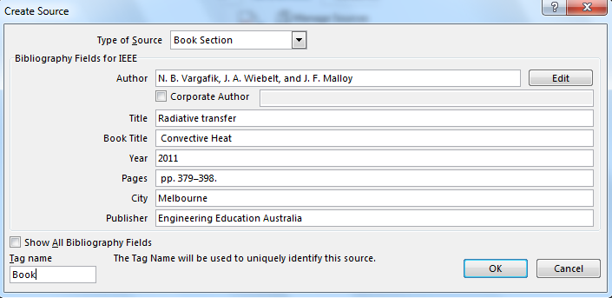

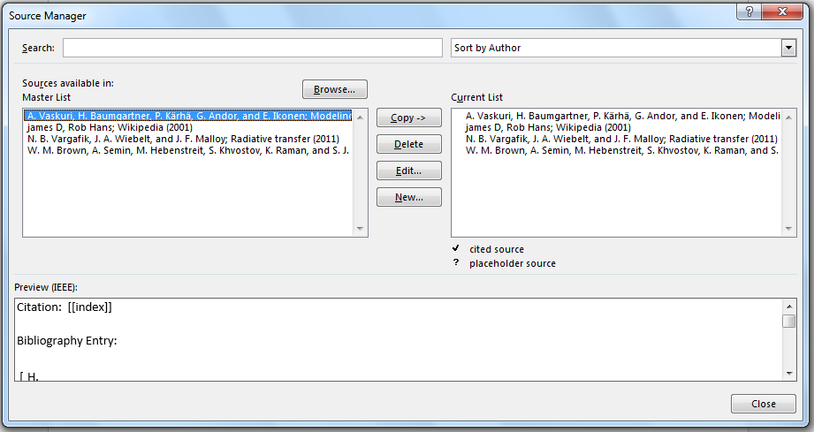

*Figure 4.3 Source Manager*

Sample Reference (IEEE Format)

|  |  |
| --- | --- |
| [1] | W. M. Brown, A. Semin, M. Hebenstreit, S. Khvostov, K. Raman, and S. J. Plimpton, "Increasing molecular dynamics simulation rates with an 8-fold increase in electrical power efficiency," in *SC '16 Proc. of the Int. Conf. for High Perf. Computing, Networking, Storage and Analysis*, Salt Lake City, Utah, 2016. |
| [2] | A. Vaskuri, H. Baumgartner, P. Kärhä, G. Andor, and E. Ikonen, "Modeling the spectral shape of InGaAlP-based red light-emitting diodes," *Journal of Applied Physics,* vol. vol. 118, no. Jul. 2015, pp. pp. 203103-1–203103-7, 2015. |
| [3] | N. B. Vargafik, J. A. Wiebelt, and J. F. Malloy, "Radiative transfer," in *Convective Heat*, Melbourne, Engineering Education Australia, 2011, p. pp. 379–398. |
| [4] | james D, Rob Hans, "Science portal, Wikipedia," Wikimedia Foundation, 5 May 2001. [Online]. Available: https://en.wikipedia.org/wiki/Portal:Science. [Accessed 19 April 2018]. |

**Appendix**

Use the style **SLIIT_Main** for the above heading.

1. **Sub Category of Appendix**

If your appendix is having sub-sections use **SLIIT_Appendix** Style for the sub heading.